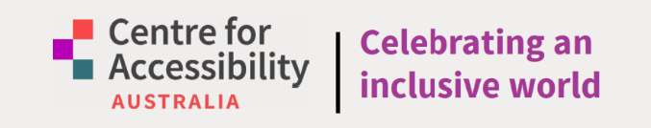

5th Birthday Edition

Celebrating Five Years of Digital Access and Inclusion.



Contents
5th Birthday Edition 1
Celebrating Five Years of Digital Access and Inclusion. 1
Chairperson’s Report 5
Dawn McAleenan 5
Message from our CEO 6
What Is Digital Accessibility? 7
Digital Accessibility as A Human Right 8
Prevalence of Disability in Australia 8
What is CFA Australia? 9
Mission 9
Vision 9
Promoting Digital Inclusion 10
Objective 1: Empowering Accessibility at CFA Australia 10
Objective 2: Enhancing Audio Description and Captioning 10
Objective 3: Expert Assistive Technology Support 10
Objective 4: Training for Digital Empowerment 10
Objective 5: Advocating for Inclusive Practices 10
Objective 6: Research and Innovation 10
Objective 7: Representation and Governance 11
What We Do 12
Our Team 13
Board Members 13
CFA Australia Team 13
Evolving for Impact: The CFA Australia Story 14
The Australian Access Awards 15
The Accessibility Hall of Fame 15
2023 Inductees 15
2021 Inductees 15
2019 Inductees 16
Acknowledgements 16
Spotlight: Jane McInnes – 2021 Accessibility Hall of Fame Inductee 17
Membership 19
Membership Benefits 19
Free Digital Accessibility Helpdesk 20
Case Study 21
With Support From ACCAN 21
Systemic Advocacy Grant 22
Part 1 - Discovery Project 22
Part 2 - Engage, Survey, Report. 22
Part 3 - Discovery Workshops 22
Part 4 - Audit to Implementation Roadmaps 23
Part 5 - Policy Development Advocacy 23
Part 6 - Celebrating Success in Digital Access 23
Part 7 - Impact Measurement and Recommendations 23
Accessibility audits and roadmaps 23
Discovery Workshops 24
Online course 25
CFA Australia and Brayco Partner to Donate 100 Laptops to People with Disability 27
CFA Australia Supports Western Australian Museum’s Accessibility Efforts 28
The Next Step in Digital Accessibility: WCAG 2.2 29
CFA Australia Supports Global Web Standards as W3C Member 30
Australia Formally Adopts WCAG 2.2 Level AA! 31
WA Universities’ Collaboration with CFA Australia to Support Students with Disability 32



Chairperson’s Report

Dawn McAleenan

Once again it is my privilege to present the Chairperson’s Report for 2025. What began as a bold idea has, in just five years, become a leading force in digital accessibility.
Centre for Accessibility Australia (CFA Australia) has grown into a professional, nationally recognised organisation that is transforming lives and setting new benchmarks in inclusion.
From launching the Australian Access Awards—now a major national event celebrating accessibility excellence —to expanding our Helpdesk and delivering front line support across regional WA, CFA Australia is driving meaningful change on the ground and at policy levels.
Our influence reaches globally, through contributions to W3C and ISO standards, and nationally, by championing updates to the Disability Discrimination Act.
With over 75% of our team living with disability, we lead by example, creating real opportunities and breaking down barriers.
Backed by a passionate Board and strong leadership from CEO Dr. Scott Hollier, CFA Australia has matured into a resilient, strategically focused organisation.
As we celebrate this milestone, we’re proud of what’s been achieved—and excited for what’s still to come.
Dawn McAleenan
Chairperson

Message from our CEO
Centre for Accessibility Australia started as a dream given form, commencing in 2018 as an initiative to support people with disability in achieving independence through technology. Through the work of the initial founders, including myself, it was exciting to see a website come together, supporting resources published online and the start of the Australian Access Awards in 2019.
Realising the passion of people in the digital access space wanting to do more, a Board came together in 2020 at a critical time for digital access. COVID-19 caused an urgent need for organisations to move online, and our incorporation as a not-for-profit organisation arrived just in time to provide that critical support to people with disability in the workforce and their employers to help ensure their work processes were accessible.
Fast forward five years, and it's truly remarkable to think that we now have 14 staff, the majority of whom have lived experience of disability, including myself. We're privileged to utilise our skills and talents to continue our mission of ensuring independent access to digital technologies for people with disability, their families, and carers across Australia.
Through initiatives like our free assistive technology helpdesk, the Australian Access Awards (now heading into its fourth celebration), support for our members via the Friends of CFA Australia program, and partnerships with organisations that regularly seek our expertise for audits and training, it's been an incredible journey working alongside fantastic staff, valued grant partners, dedicated clients, and an outstanding Board.
Thank you for taking the time to read about our journey in this report and thank you for your support of our incredible social movement.
Dr. Scott Hollier
CEO of Centre for Accessibility Australia

What Is Digital Accessibility?
In today’s digital age, access to technology is no longer a luxury, but a necessity. For people with disability, digital access is crucial for independence, social inclusion, and equal opportunities. However, many barriers remain, excluding millions from the benefits of technology.
“Accessibility is a human right.” Dr. Scott Hollier CEO of Centre for Accessibility Australia
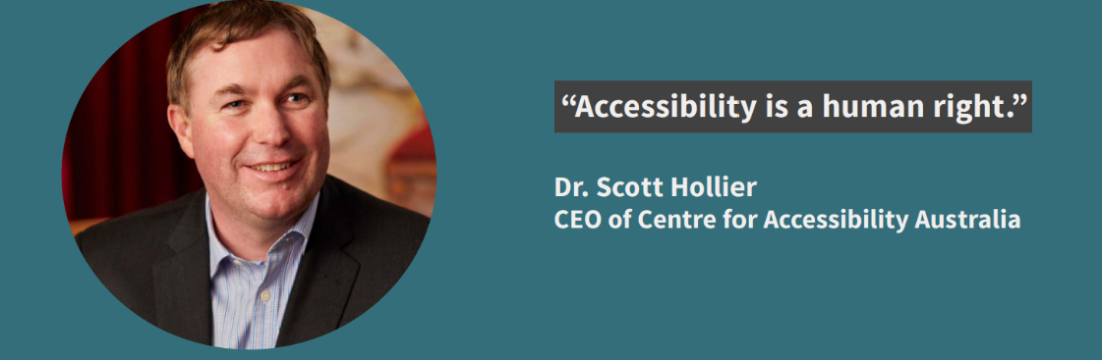
Digital accessibility refers to the design of digital spaces to ensure navigation by people with disability. This includes websites, applications, and online platforms that are compatible with assistive technologies such as screen readers, keyboard-only navigation, and closed captions.
Imagine relying on assistive technologies to use the internet, only to encounter inaccessible websites and applications. Simple tasks like online shopping, banking, and checking utility bills become daunting challenges. For instance, online forms require correctly tagged fields for screen readers to function properly, while buttons need clear descriptive text for users to understand their purpose.
By breaking down digital barriers, we ensure equal access to information and services, unlocking unrestricted opportunities for social interaction, education, and employment.

Digital Accessibility as A Human Right
Accessibility is a fundamental human right, essential for equal participation in today’s digital society.
Inaccessible digital environments can lead to social isolation, exclusion, and marginalisation. By prioritising digital accessibility, we can build a more inclusive, equitable, and just society, where everyone can thrive and reach their full potential.

Prevalence of Disability in Australia
According to the Australian Bureau of Statistics (ABS), in 2022, 5.5 million, approximately 21.4% of the population had disability, up from 17.7% in 2018. This represents an increase in the already significant portion of the population, highlighting the importance of inclusivity and accessibility in all aspects of life.
In addition, over half (54.2% or 3.0 million people in Australia) used aids or equipment because of their condition.
Reference:
Disability, Ageing and Carers, Australia: Summary of Findings, 2022 | Australian Bureau of Statistics

What is CFA Australia?
Centre for Accessibility Australia (CFA Australia) is a disability-led, award-winning, not-for-profit organisation.
Led by CEO Dr. Scott Hollier, who is legally blind, our team is passionate about bridging the accessibility divide. The majority of our team members have a disability or are neurodiverse, ensuring that our organisation is truly representative of the community we serve and that our work is informed by lived experience and expertise.

Mission
To empower the accessibility movement by advocating the implementation of universal equal access.

Vision
An inclusive world without accessibility barriers to content or spaces.

Promoting Digital Inclusion
At CFA Australia, we believe that equal access to technology is a fundamental right. We envision a world where everyone can fully participate in the digital landscape. Our mission is to bridge the digital divide and promote inclusive practices.
To achieve this vision, we focus on seven key objectives:

Objective 1: Empowering Accessibility at CFA Australia
We believe everyone deserves equal opportunities through technology. Our free tools and resources help people with disability harness mainstream products’ built-in assistive features, bridging the digital divide. Ensuring equal access to digital information is vital for people with disability to fully participate in society, exercise their rights and access essential services, education, and employment opportunities.

Objective 2: Enhancing Audio Description and Captioning
We provide vital resources on audio description and captioning in order to empower individuals who are blind or with low vision, or who are deaf or hard of hearing, to fully engage with media and entertainment. According to the Department of Health, Disability and Ageing, as of 2024, about 3.6 million Australians have some level of hearing loss. With the numbers estimated to double to approximately 7.8 million people in 2060, showing the growing importance for audio descriptions and captioning to provide equal access to culture and education, leading to increased social participation and cognitive growth of people with disability.

Objective 3: Expert Assistive Technology Support
Our Assistive Technology Helpdesk delivers personalised guidance, ensuring people with disability find and effectively use devices tailored to their needs. Specialist support boosts digital confidence, fostering independence and effective technology use, leading to better education, employment, and daily life outcomes.

Objective 4: Training for Digital Empowerment
Through comprehensive training programs, we equip people with disability to unlock the potential of assistive technologies. Comprehensive training in assistive technologies enables people with disability to fully participate in the digital landscape.

Objective 5: Advocating for Inclusive Practices
CFA Australia advocates for digital and physical accessibility, educating organisations and individuals on inclusive processes and practices. Accessibility advocacy fuels systemic change, shaping policy reforms and inclusive infrastructure.

Objective 6: Research and Innovation
We investigate emerging accessibility challenges, developing solutions and influencing policy reforms. Ensuring equal access to emerging technologies requires proactive solutions, research, and policy reforms to bridge existing accessibility gaps and foster inclusive social progress.

Objective 7: Representation and Governance
Our commitment to representation ensures people with disability are integral to our decision-making processes. Diverse perspectives from people with disability drive better governance, leadership, and community outcomes.

What We Do
- Advocacy (Objective 5) We champion digital accessibility through policy, research, and community engagement.
- Research (Objectives 1, 2, 5, 6, 7) We conduct studies and publish insights to inform accessibility best practices.
- Helpdesk (Objectives 1, 2, 3) Providing expert guidance and resources to individuals and organisations seeking to improve digital accessibility, offering personalised support to address unique challenges and concerns.
- Australian Access Awards (Objective 5) We proudly present these prestigious awards to recognise and celebrate outstanding achievements in digital accessibility, promoting excellence and innovation in the field.
- Training Services (Objectives 2, 4) We provide education and training to organisations and individuals.
- Auditing Services (Objectives 5) We assess digital products for accessibility and provide recommendations.

Our Team
The Board at CFA Australia is comprised of a passionate and experienced team of staff and volunteers, who collectively bring a wealth of knowledge and expertise in digital accessibility and disability services, driving our mission forward.

Board Members
Dawn McAleenan (Chair)
Stewart Luxton (Deputy Chair)
Stanley Lai (Treasurer)
Dr. Michelle Bunn (Secretary)
Scott La Vertu
Yuemei Lim
Jackie Weinman
Marina Re

CFA Australia Team
Dr. Scott Hollier
Aarthi Gurunathan
Christopher Edwards
Laetitia Thompson
Bryan Benjamin
Nicholas Kapirnas
Colleen Hunter
Jasmine Lee
Kieran Hayward
Alyssa Velasco
Chris Pryor
Owen Raspa
Mitsuyo Nakamura
Rina Matsubura
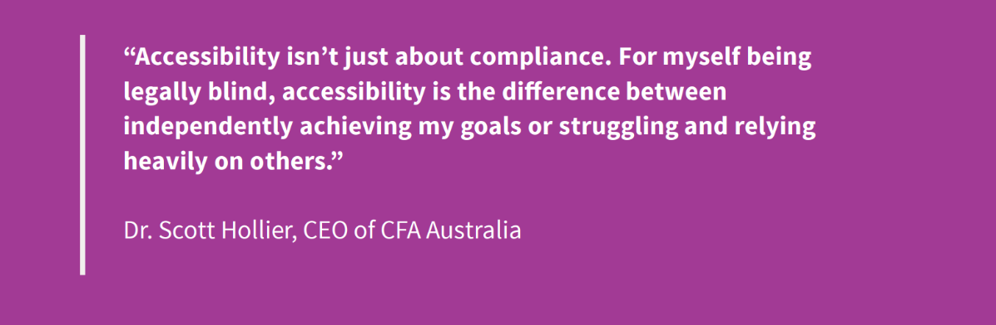

Evolving for Impact: The CFA Australia Story
Over the past five years, our team at CFA Australia has undergone significant growth and evolution, driven by our commitment to recognising and utilising the unique skills and strengths of our team members. From humble beginnings in a rented room in Fremantle, we've expanded to an office in the Belmont Hub, surrounded by like-minded charities and not-for-profits. Our team has grown to 14 dedicated staff members, and we've expanded our skillset to meet the needs of our organisation. Many of our team members have taken on new roles that showcase their talents and passions.
For instance, Bryan Benjamin has transitioned from Junior Digital Accessibility Analyst to Business Development and Grants Coordinator, leveraging his skills. Laetitia Thompson, our Senior Digital Content Editor, has expanded her role to running workshop sessions as well, sharing her specialisation and lived experience with others. Nicholas Kapirnas has taken on the role as our Senior Digital Media Coordinator, utilising his photography and filmmaking expertise and background to drive our visual storytelling from a lived experience lens. Christopher Edwards has also added on to his role as an auditor to becoming the auditing team’s Technical Lead, bringing his years of technical digital accessibility expertise to the forefront.
As our auditing team has grown, we've welcomed Chris Pryor to manage the team as an Operations Manager. With his valuable experience and leadership skills, Chris has quickly become a crucial member of CFA Australia. To date, we've conducted over 180 digital accessibility audits, including our audits that we completed in line with various grant-funded projects such as the Digital Access WA Project and “Higher Education for All” research project, helping organisations across various sectors improve their digital accessibility.
Our research initiatives, such as our “Cancellations for All” report, which was funded by the Australian Communications Consumer Action Network (ACCAN), has also had a national impact, driving positive change and promoting inclusivity in the telecommunications sector.
CFA Australia has also become an award-winning not-for-profit, having been recognised by the City of Fremantle and City of Belmont. As a disability-led organisation, we're proud to be driven by the perspectives and expertise of people with disability, prioritising their voices and experiences in all of our work. This approach enables us to create more effective and inclusive solutions, driving positive change in the lives of people with disability.
Looking ahead, we're excited to host the 4th Australian Access Awards in November 2025. The Access Awards recognises and honours organisations that demonstrate best practice in digital accessibility. This event will celebrate the outstanding achievements of organisations that are committed to creating inclusive and accessible digital environments.

The Australian Access Awards
The Australian Access Awards, hosted by CFA Australia, recognises and celebrates the outstanding contributions of people and organisations to digital accessibility in Australia.
The awards program, held every two years, acknowledges organisations and individuals demonstrating exceptional commitment to delivering accessible outcomes for Australians living with disability. Nominations are free for anyone, with an independent judging panel deciding on the winners.
Our award winners range from grassroots initiatives to major corporates, showcasing the diversity and excellence of digital accessibility efforts in Australia.
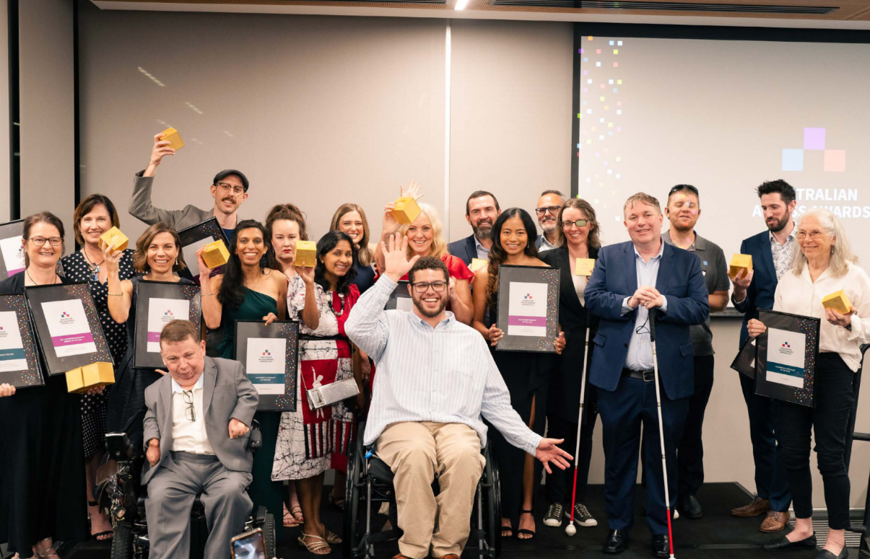

The Accessibility Hall of Fame
The Accessibility Hall of Fame honours individuals who have made significant contributions to promoting and adopting digital access in their work environment and community. Nominated by people with disability, their families, and carers, these individuals have demonstrated remarkable dedication to creating a more digital landscape.

2023 Inductees
- Dr Liddy Nevile: A pioneer in the digital accessibility movement in Australia, Liddy led OZeWAI for several decades and contributed to international standards, including DC and ISO metadata and accessibility standards.
- Vithya Vijayakumare: A champion of digital accessibility, Vithya has driven the Perth Web Accessibility Camp for nearly a decade, empowering organisations and fostering accessibility awareness through workshops.

2021 Inductees
- Jane McInnes – See Spotlight article for more details.

2019 Inductees
- Gian Wild: A pioneer in the accessibility industry, Gian has worked with the W3C Web Content Accessibility Guidelines (WCAG) Working Group and contributed to the development of WCAG2. She is the founder of AccessibilityOz and has worked with the United Nations to promote digital accessibility.

Acknowledgements
The success of the Australian Access Awards would not have been possible without the generous support of our Sponsors:
• OZeWAI • Cahoots • VisAbility • Infosys • Coles • ANZ • The Bray Family Fund through Fremantle Foundation • Department of the Premier and Cabinet Office of Digital Government • Brayco • Dormatics Australia • Australian Communications Consumer Action Network (ACCAN) • AbleDocs • Centre for Inclusive Design • Attitude Foundation • Inclusion Solutions • Digital Gap Initiative
CFA Australia also gives thanks to our independent panel of judges, DADAA and Media on Mars for their contributions.
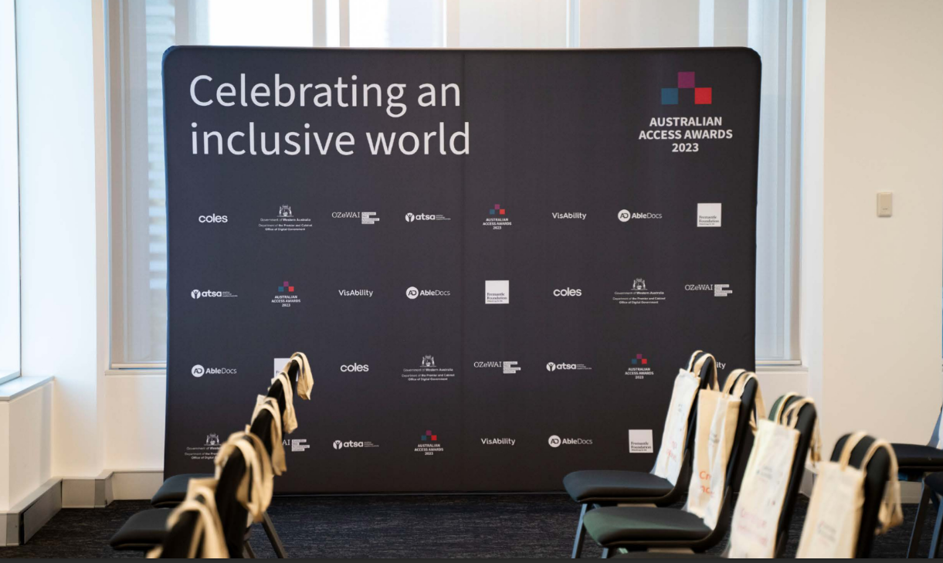

Spotlight: Jane McInnes – 2021 Accessibility Hall of Fame Inductee
CFA Australia recognises the power that individual action can make for progressing the digital accessibility movement. It was our honour to celebrate Jane McInnes, Digital Communications Specialist for Government Employees Superannuation Board (GESB), Winner of the ‘Accessibility Person of the Year’ at our 2021 Australian Accessibility Awards.
Jane was also inducted into CFA Australia’s Hall of Fame in recognition of her leadership and incredible initiatives, including the successful implementation of the GESB website and the ‘Retirement Planning Calculator’ that achieved outstanding compliance against WCAG 2.0 Level AA.
“It is great that CFA Australia recognises organisations, designers, developers and content creators who work hard to implement accessibility across their online communication tools and resources, and the award is such a great event celebrating best practice in accessibility.”
Jane McInnes
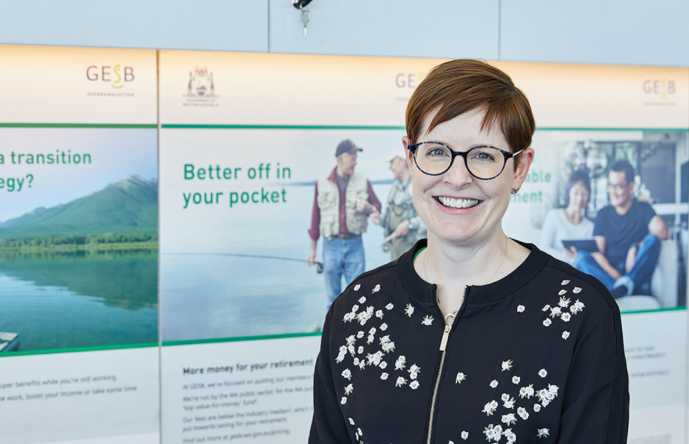
Having worked across communications and digital sectors for the past 19 years, Jane is now the Digital Communications Specialist for GESB. GESB is a WA State Government superannuation fund responsible for managing the super and retirement savings of 248,000 public sector workers– an organisation she credits for placing genuine importance on accessibility in all levels of management.
“It is a key consideration when we develop new online content and initiatives. Accessibility isn’t just about compliance for us; it’s about helping make a difference in people’s lives.”
All Australians deserve equal access to managing their savings online. With a lived experience of chronic migraines, Jane recognised the barriers still facing her community. She understood the importance of assistive features such as dark mode, display settings across devices, audio options, responsive design and the removal of flickering lights on digital content.
Jane's combination of lived experience and professional expertise in all things digital accessibility empowered her to take ownership and drive a suite of successful, award-winning digital accessibility initiatives.
“We have welcomed the opportunity to see GESB’s journey with digital accessibility. Jane is an incredible advocate for accessibility, and it has been wonderful to see her work being recognised through the Awards.” - Dr. Scott Hollier, CEO of CFA Australia

Membership
Join the movement towards a more inclusive digital world with CFA Australia! Despite progress, digital barriers still hinder people with disability. Our Friends of CFA Australia program allows individuals and companies to support accessibility initiatives while enjoying benefits like discounted audits, training, and consultancy services.
Your contribution empowers our free Helpdesk and brings us closer to a digitally inclusive world. Visit our membership page to learn more and join us in promoting digital inclusion for all.
As a member, you’ll not only support employment opportunities for people with disability and drive long-term change but also receive exclusive perks!


Membership Benefits
- Accessibility Support Pack featuring 5 hours of support for members yearly (includes access to our disability-led hotline and general consultancy)*
- Free attendance to 1 half-day online or face-to-face CFA Australia training session (1 person per organisation) – with a 10% discount on subsequent training sessions or for additional staff
- 10% discount on all CFA Australia services such as audits, training and consultancy
- 10% discount on speaking engagements
- 20% discount on events
- Friend badges that can be displayed in tender documents, marketing material and on your website
- An exclusive invite to our State of Accessibility Digital Address (twice a year)
- Access to the CFA Australia Newsletter ‘Accessibility Tips and Tricks’
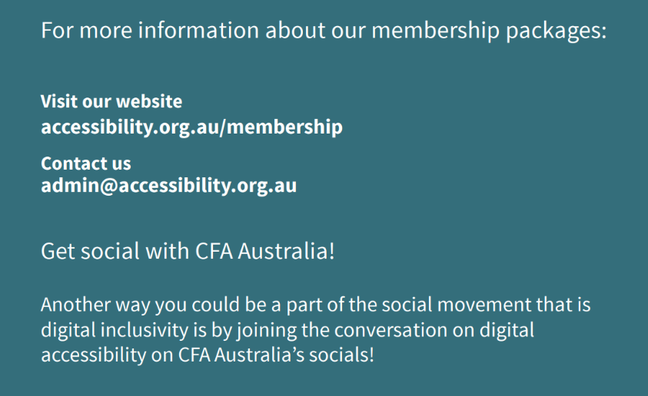

Free Digital Accessibility Helpdesk

At CFA Australia, we’re dedicated to supporting individuals with disability and organisations on their path to digital accessibility.
Our Helpdesk service, led by a team of experts with disability, offers personalised guidance and assistance.
Our free Helpdesk is designed to support people with disability, their families, and carers through:
- Enabling accessibility features on devices
- Navigating everyday online services
- Finding alternative accessible websites and apps
In addition to direct support, we provide access to a wealth of tutorials and online resources to enhance knowledge and independence.
Thanks to the contributions of student interns from Curtin University, we have also recently been able to share detailed accessibility instructions for Amazon Fire TV and Apple TV, making it easier for everyone to access your favourite streaming services.
Our Helpdesk embodies our commitment to equal access for all. We believe everyone deserves to harness the potential of technology and the internet with confidence. Let us help you navigate the digital world with ease.

Case Study

With Support From ACCAN
At CFA Australia, we are thankful to have received funding from ACCAN for the “Cancellations for All” research project as part of an independent grant funding round.
The comprehensive reports, which can be found on our website for free, helps consumers with disability compare mobile SIM providers in Australia, based on their accessible support and cancellation services.
The reports enable consumers with disability to easily identify mobile SIM providers with accessible support and cancellation services in Australia.
We share ACCAN’s commitment to promoting digital accessibility and ensuring equal access to telecommunications services.
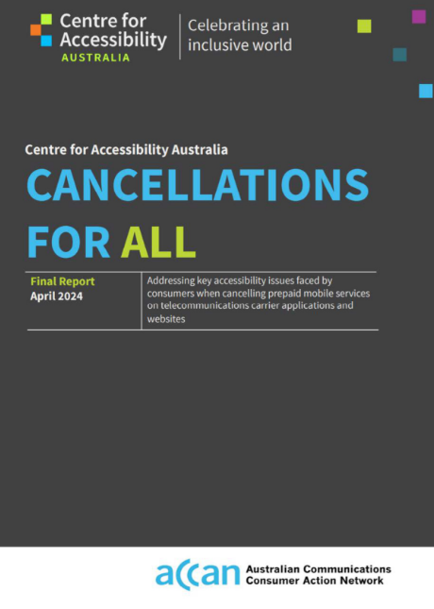

Systemic Advocacy Grant
In 2022, CFA Australia was provided grant funding by the Department of Communities of Western Australia (DoC) for a new state-wide initiative called The Digital Access WA Project.
As part of this initiative, CFA Australia aimed to influence policy and produce outcomes which embed awareness of and the need for digital accessibility as a standard in the WA government, education, and disability sectors. The initiative was split into 7 parts, with the goal to ensure that all people with disability have equal access to information and opportunity.

Part 1 - Discovery Project
- CFA Australia engaged, listened to and amplified the views of people with disability to understand and advocate directly for the changes needed to enhance digital access in WA. In line with this, CFA Australia produced 3 digital accessibility ‘explainer-series’ videos led by people with disability who identified obstacles to digital access and offered practical solutions to overcome them. These videos included both Auslan interpretation as well as captioning, ensuring accessibility for all. The 3 videos are:
- What is Digital Accessibility?
- How Digital Accessibility Affects Me
- Why Digital Access is Access for All

Part 2 - Engage, Survey, Report.
- CFA Australia produced benchmarks and surveys that determined the current state of accessibility service provision in WA reporting sector by sector, in particular, the not-for-profit and primary and secondary education sectors. CFA Australia conducted an Enquiry of Interest (EOI) for the not-for-profit sector and primary and secondary schools in WA to identify potential organisations to provide digital accessibility audits and roadmaps for.

Part 3 - Discovery Workshops
- CFA Australia created practical and disability-led digital access education and outreach programs, delivered as workshops. Although only 3 regional workshops in WA were initially planned as part of the grant funding, thanks to the generous support of the DoC, we were able to go organise for 7 regional workshops, alongside 7 workshops in Perth’s metropolitan area. Specifically, these workshops were held at:
- Broome
- Bunbury
- Busselton
- Esperance
- Geraldton
- Kalgoorlie
- Mandurah
- York
- Perth Metro
All of the workshops were delivered by staff members of CFA Australia with lived experience of disability alongside expert knowledge in the space of digital accessibility.
- This part of the project also featured the creation of an online course for introductory and advanced digital accessibility training to upskill organisations across WA. The course was curated and produced for people who could not attend the regional workshops, ensuring everyone across WA could have access to digital accessibility education. The curriculum was developed in collaboration with the University of the Sunshine Coast, a recognised leader in regional education in Australia, and Dr. Scott Hollier, a renowned accessibility expert with lived experience of disability and practical experience in authoring similar courses. Although only 2 modules were initially planned as part of the grant funding, we were able to produce 6 modules which continue to be available free-of-charge.

Part 4 - Audit to Implementation Roadmaps
- CFA Australia provided free digital accessibility audits to 21 not-for-profit organisations and 7 primary and secondary schools in WA. This went beyond the initial grant expectations of 25 audits. Audit-to-implementation roadmaps were developed to outline the digital accessibility issues and to recommend the steps needed to improve and maintain accessibility as well as guidance to making the required accessibility changes on their website.

Part 5 - Policy Development Advocacy
- CFA Australia played a vital role in providing policy support and consultation to support the WA government’s move to making WCAG 2.2 the required digital standard in WA.

Part 6 - Celebrating Success in Digital Access
- The Digital Access WA Project was concluded by a celebratory event held in-person at the Disability in the Arts, Disadvantage in the Arts, Australia’s (DADAA) venue in Fremantle, WA, in June 2025 . In line with the summation and conclusion of the grant deliverables over its successful 3-year span, CFA Australia produced 2 videos in-house to present the impact made throughout the initiative as well as to highlight success stories and show the benefits of reducing the digital divide to decision makers, workplaces, and communities.

Part 7 - Impact Measurement and Recommendations
- As part of the Digital Access WA project, CFA Australia approached The Behaviour Change Collaborative (BCC) to lead the impact measurement and evaluation of the initiative from a third-party perspective. In particular, CFA Australia looked to measure the impact of the Discovery Workshops, the online course, and the accessibility audits and roadmaps. Impact measurements included pre-and post- surveys for all initiative deliverables.

Accessibility audits and roadmaps
- Those who participated in CFA Australia’s website accessibility audit almost universally felt it to be highly useful for their organisation, with 95% reporting that the process was informative and 90% agreeing that it provided clear guidance about how to increase their organisation’s digital accessibility.
- The usefulness of the audit process was evidenced by the impacts it had, with participants recording a substantial uplift in their knowledge about digital accessibility post-audit.
- Notably, close to two-thirds of those who completed the audit process felt they subsequently had moderate or high technical knowledge about how to make their organisations’ website accessible.
- The evaluation indicated that the audit process had a positive impact on the accessibility of participating organisations’ websites. For example, half of the participants indicated that at least three-quarters of their website was accessible following implementation of the audit actions, compared to only 20% prior to the audits.
- Following completion of CFA Australia’s website audit process, representatives from participating organisations were highly likely to believe that website accessibility is important, showed very high levels of satisfaction with the audit process, and were almost universally likely to recommend the audit process to other organisations.
- Participants’ verbatim feedback illustrates the high regard to the audit process and CFA Australia’s disability-led team were held in by those who took part.
- Here are some quotes from participating organisations:
- “The results, report and roadmap (of the accessibility audit) were and are extremely useful in providing an evidence-based platform for us to use to make changes and prioritise further updates and ongoing reviews. Thank you”
- “The audit process for our website was very simple for our organisation and has been invaluable. To have an accessibility expert from the Centre for Accessibility review of website and receiving a clear and concise report, has allowed us to identify what adjustments are necessary to make our website accessible for all users which is a priority for us as an organisation supporting parents and carers of children with disability.”
- “The audit process was designed by a person with lived experience. This is distinctly different from a process designed by someone with only academic and technical knowledge.”

Discovery Workshops
- More than 90% of attendees felt that the workshops helped them understand the usefulness of assistive technologies, gave them insights into the WCAG standards and informed them about how to use automated checking tools.
- Most importantly, 93% of those who attended a workshop said that they were more likely to act to improve their organisation’s digital accessibility. This last indicator suggests that the learnings from the workshops are likely to be applied by attendees and therefore create a meaningful improvement in digital accessibility for people with disability.
- There were also very high levels of agreement that the videos that were created as part of the DoC grant deliverables were a valuable addition to the workshops, with over 90% finding the videos informative, understanding, and enhancing of their understanding of digital accessibility from the perspective of people with a disability.
- The positive impacts of the workshops are evidenced by the wonderful feedback received as part of the post-audit survey:

- “As a communications and engagement officer, it was fantastic to have the opportunity to learn about Digital Accessibility. My prior knowledge was minimal so I was very keen to learn more about how I can improve both personally and professionally online. Since the workshop, I have also been able to share what I learned with my colleagues. Through spreading the word about my learnings, I hope to drive improvement in accessibility in my organisation. I cannot thank the Centre for Accessibility enough for the fantastic opportunity to attend these workshops. I learned so much.”
- “I recently attended the Digital Access workshop in Esperance, and I was truly impressed by the wealth of insightful information shared. As someone in a wheelchair with significant involvement in the disability sector, I thought I already had a good understanding, but the workshop taught me so much more. The knowledge I gained is already helping us improve our website, making it more accessible for people with vision impairments and other disabilities. I'm extremely grateful for the opportunity to attend locally in Esperance, rather than having to travel elsewhere.”
- “The workshops were specific and practical. The topics were broken up into theory, hands on practical experiences e.g. using speech support tools on your phone or laptop as well showing case studies/examples of facilities that had issues and how they could be improved. This workshop made the learning relatable and being able to complete within the southwest meant that the other attendees from other organisations were experiencing similar issues and we could relate to each other”

Online course
- Among those who completed the course, their reported experiences of it were overwhelmingly positive, with all aspects of the course content and format rated extremely highly.
- All respondents felt that the course content was useful and the online format easy to navigate.
- The effects of the course on topic knowledge and understanding were very highly rated, with more than 90% of those who completed the course feeling that it had increased their understanding of all content areas.
- The course had very positive impacts on participants’ self-reported knowledge of digital accessibility overall, with this increasing significantly pre vs post course completion (62% to 82%).
- The course was even more effective in raising participants’ confidence in their skills to improve digital accessibility for people with disability. Prior to the course, less than half of those enrolled felt confident in their skills (46%). Among course graduates, this rose significantly and substantially to 97% who felt confident in their skills in digital accessibility.
- These results were extremely positive as an improvement in both knowledge and confidence suggested that graduates would be effective in implementing course learnings going forward.
- When asked about the most valuable insight or skill gained from the course, participants provided the following feedback:
- “The practical tips to ensure documents are accessible, as well as the break down of the WCAG into simple principles. I also really like the explanation of the difference between inclusive design, accessibility and universal design. Makes sense!”
- “It was very useful to have screen recordings walking through how to correct accessibility issues in Word and Adobe Acrobat Pro. This helped explain the tag tree and how to edit elements”
CFA Australia would like to sincerely thank the DoC for the incredible opportunity that the Systemic Advocacy grant provided for this initiative and bridging the divide for people with disability in WA.

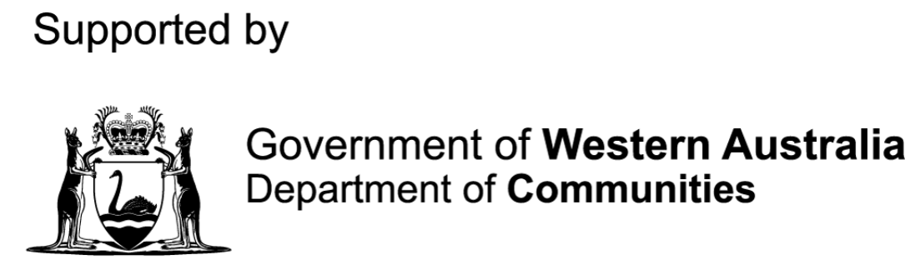



ARTICLES

CFA Australia and Brayco Partner to Donate 100 Laptops to People with Disability

In an exciting initiative, CFA Australia partnered with Brayco to donate 100 laptops to individuals with disability, promoting digital inclusion and enhancing their daily lives.
Thanks to Brayco’s generous funding, the laptops came equipped with:
- Windows 11 operating system, featuring the latest accessibility features
- Essential Microsoft applications like Word, PowerPoint, and Excel, supporting productivity and independence.
To date CFA Australia has donated 94 laptops to people with disability in need throughout Australia.
Dr. Scott Hollier, CEO of CFA Australia, emphasises the significance of this donation:
“This generous support will make a real and profound difference in the lives of people with disability, enabling them to harness the power of accessibility technologies and gain greater independence.”

CFA Australia Supports Western Australian Museum’s Accessibility Efforts
CFA Australia has worked with the Western Australian Boola Bardip Museum on a series of projects aimed at enhancing the museum’s digital accessibility.
Our team of experts has:
• Conducted an accessibility audit of their social media platforms
• Developed an accessibility report for the “To the Moon” exhibit, providing actionable recommendations for improvement
• Created an accessibility Visual Story for the museum’s website for the ‘To the Moon’ exhibit.
• Facilitated a workshop with the museum’s marketing team on accessible social media practices.
CFA Australia is committed to supporting organisations in their efforts to become more accessible and inclusive. We look forward to continuing our work with the Western Australian Museum to make digital experiences more accessible for all.

The Next Step in Digital Accessibility: WCAG 2.2
As we celebrate our 5th anniversary, it's worth noting that the past five years have seen significant improvements in digital accessibility, driven in part by important updates to international standards. One notable milestone was the release of the Web Content Accessibility Guidelines (WCAG) 2.2 in October 2023.
In October 2023, the World Wide Web Consortium (W3C) released the latest update to the Web Content Accessibility Guidelines (WCAG 2.2). This new version builds upon the previous guidelines, introducing 9 additional success criteria to improve web accessibility. WCAG 2.2 focuses on enhancing the digital experience for users with disability, addressing emerging technologies, and closing gaps in existing guidelines.
Key updates include:
- Improved focus visibility and accessibility
- Enhanced authentication and authorisation processes
- Better handling of non-text content and images
- Increased mobile device usability
The adoption of WCAG 2.2 is a crucial step forward in creating a more accessible and equitable digital landscape. By prioritising WCAG 2.2 compliance, organisations can ensure their digital content is more inclusive, user-friendly, and compliant with global accessibility standards.
In April 2025, Australia formally adopted WCAG 2.2 Level AA as a minimum, reflecting the country's commitment to staying up-to-date with the latest international standards for digital accessibility.

CFA Australia Supports Global Web Standards as W3C Member
CFA Australia is proud to be a member of the World Wide Web Consortium (W3C), the international community that develops and maintains web standards to ensure the long-term growth and stability of the web. As a W3C member, CFA Australia is committed to advancing web accessibility and promoting the development of web standards that benefit all users.


Australia Formally Adopts WCAG 2.2 Level AA!
The Australian Human Rights Commission (AHRC) published a media release on the 2nd of April 2025 providing “new guidelines to assist organisations and businesses to meet their legal obligations under the Disability Discrimination Act 1992 when providing digital products and services”.
These advisory notes were issued by the AHRC under section 67(1)(k) of the Disability Discrimination Act 1992, which authorises the AHRC to issue guidelines for the purpose of avoiding discrimination.
As part of these new guidelines, Australia formally adopted WCAG 2.2 Level AA compliance as a minimum, updating from the former WCAG 2.0 that had been the Australian recommendation since 2014. This marked a significant improvement in digital accessibility within Australia, as the updated guidelines includes support for mobile accessibility and additional guidance for people with a cognitive disability.
Some other major advancements included:
- When developing tools that enable us contributions, organisations should adhere to ATAG 2.0 by using WCAG 2.2 rather than WCAG 2.0 as appropriate.
- AS EN 301 549 requirements must be fulfilled by all digital products, including hardware. However, WCAG 2.2 should be used where appropriate, as AS EN 301 549 refers to WCAG 2.1.
“This marks a major opportunity for Australia to embrace emerging technology and their requirements. We look forward to States, Territories and local governments following suit with their policy updates to improve the lives of people with disability all around the nation”.
- Dr Scott Hollier, CEO and Co-Founder for Centre for Accessibility Australia

WA Universities’ Collaboration with CFA Australia to Support Students with Disability
CFA Australia values the opportunity to contribute to accessible digital education, working closely with institutions to create more inclusive online environments.
5 of Western Australia’s top universities supported a research project designed by CFA Australia to improve digital accessibility standards for students with disability. The “Higher Education for All” research project was funded by the Department of Communities of Western Australia in 2022 and created in response to requests from people living with disability – 27 current and prospective students – who contacted CFA Australia for help to navigate university websites.
The study highlighted common digital accessibility issues on university websites, including those to do with colour contrast, inaccessible navigation and heading structure, visible focus and even PDF accessibility. In addition, students commented on the need for an accessible campus map and improved options for contacting universities, either for disability-specific support, or to raise complaints about digital access.
Participating universities received training to ensure their website management teams could improve and maintain standards against the World Wide Web Consortium’s (W3C) Web Content Accessibility Guidelines (WCAG) 2.1.
The study was the first of its kind in WA, providing critical benchmarking data that will become more applicable to other higher education institutes as CFA Australia continues its work across this sector.
View the “Higher Education for All” report on our website.

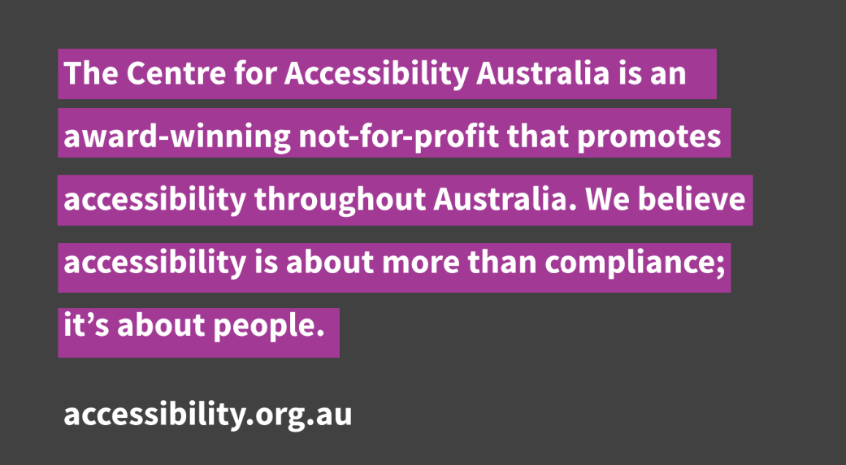

Thank you to everyone who has supported us on this journey! As we celebrate our 5th birthday, we're grateful for the opportunity to make a difference in digital accessibility. Your participation, feedback, and encouragement have been invaluable.
Stay connected with us:
Website: www.accessibility.org.au
Phone: 0466 099 101
Social Media: Facebook, LinkedIn, X, YouTube, Instagram.
Email: admin@accessibility.org.au
We look forward to continuing our journey together and making the digital world more accessible for all!

