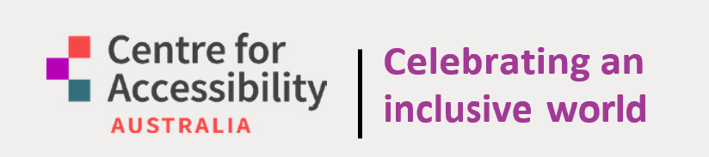

2023 Annual Report

CFA Australia respectfully acknowledges the Traditional Owners of Country across Australia and pay our respects to Elders past, present and emerging
Contents
Chairperson’s Report 4
Message from our CEO 6
What is digital accessibility? 8
Digital Accessibility 8
Why is accessibility important? 9
The research 9
What people have to say 11
What is CFA Australia? 12
Establishment & Purpose 12
Mission 12
Our Work 13
Advocacy 13
Empowering Technology 13
Research 13
Auditing Services 13
Our Team 14
Board Members 14
CFA Australia Founding Partners 14
Admin Team 14
Auditing Team 14
Our Workspace 15
Australian Access Awards 2023 15
Membership 16
Membership Benefits 16
Helpdesk 17
CASE STUDY 18
ARTICLE 21
W3C & Plain Language ISO 21
Accessible consumer developments 22
Treasurer’s Report 24
Financial Report 25
Statement by directors of the board 25
Centre for Accessibility Australia Ltd 26
Statement of Profit and Loss 26
Statement of Financial Position 27
Statement of Cash Flows 28
Statement of Change in Equity 28
Notes to financial statements 29
Note 1: Statement of significant accounting policies 29
Note 2: Reconciliation of Net Cash Provided By/Used in Operating Activities to Net Profit 30
Note 3: Members Guarantee 31

Chairperson’s Report

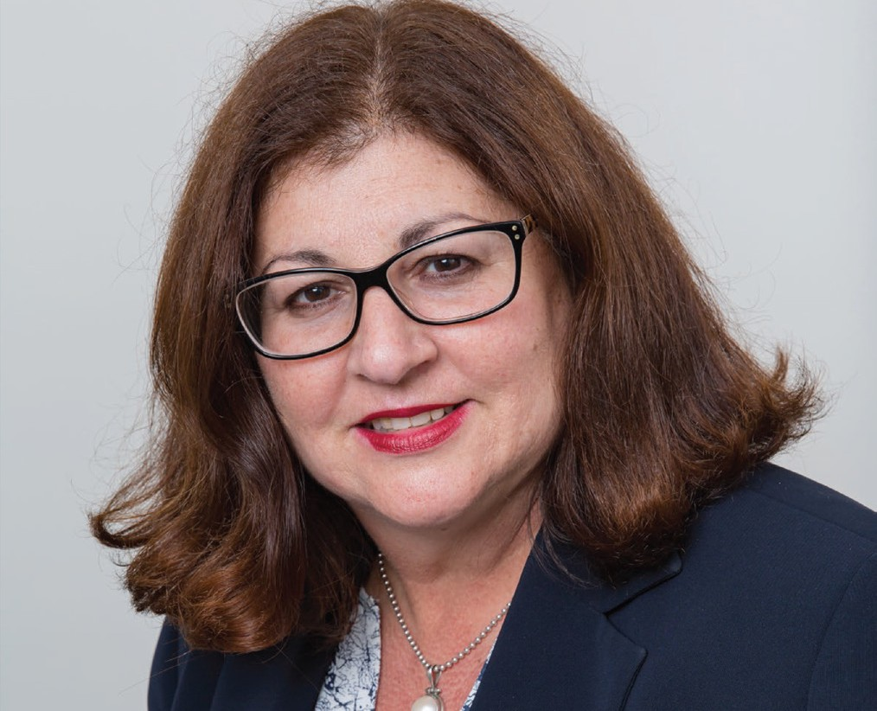

It is with great pleasure that I present the Chairperson’s Report for 2022/23. As I reflect on the past 12 months I am again impressed by the growth of the agency and the quality of the outcomes which have been achieved.

CFA Australia has a mission to improve employment opportunities by providing accessible training and workshops for organisations to encourage fully accessible workplaces. We do this by what we offer, but also what we model as an employer of choice.

In an environment with increasing focus on the Australian economy’s lost productivity – due to underemployment of people with disability – we have CFA Australia leading the way with a highly skilled and expert workforce who personally understand the challenges of digital accessibility.

For some, their position at CFA Australia is their first paid employment, and we have witnessed how this experience can result in skillsets of the team being highly desirable in the corporate world. It is always bittersweet, but we are thrilled when CFA Australia employees are sought after and embrace their next challenge.

The move to the office space in Belmont has been very well received. It is a professional base with excellent accessibility features as well as a great opportunity to network with other community-based services in the space.

The online helpdesk has now been launched and we are grateful to the Higher Education for All project which has enabled this. This is an important service and directly reflects the objective of CFA Australia to provide advice and assistance as well as access to free online resources.

The Department of Communities funded Advocacy Project has now been running for twelve months and has successfully achieved against its milestones. The provision of audits has been ramping up and this has been particularly welcomed by the NFP sector.

I am confident that the next year will bring in further growth and achievement for CFA Australia and I am also confident and grateful that the Board will continue to demonstrate appropriate governance and stewardship of this very important organisation.

As a Board we are well aware of the
extraordinary commitment of CEO Dr. Scott Hollier to deliver on the promise that CFA Australia has made to the community.

The Board in indebted to Scott and the CFA Australia Team for a very successful year, and we look forward to working together to ensure that this continues.

Marina Re
Chairperson

Message from our CEO

This financial year has been an exciting one of growth, both in terms of CFA Australia itself and the increased awareness of digital access across Australia.

With significant grants from the Department of Communities in Western Australia and the Sisters of Charity, we’ve been able to expand our digital access helpdesk both online and in person, and contributed important research on digital access in the higher education sector, and expanded our direct support of people with disability, their families and carers.
As new opportunities to help people have expanded, we’ve also moved into a new office this year which has provided new opportunities to undertake our important work.

Consumer trends such as voice control in Windows, live captioning support at the operating system level and remakes of video games including accessibility features not found in the original, are all examples of information that our highly skilled staff continue to research and share to support community participation.

While our mission focuses strongly on direct support of people with disability, we also significantly participate in national and international accessibility developments. This financial year we’ve been particularly busy in working with the World Wide Web Consortium (W3C) which produces the Web Content Accessibility Guidelines (WCAG) standard becoming a W3C member organisation. We also actively contribute in the development of the new ISO Plain Language standard and it’s been great to see a greater focus in this area.

We are also grateful to the organisations over the year that have continued to engage with our auditing, training and consultancy services and our ever-increasing rate of membership.

It’s our great pleasure as a disability-led organisation – with a majority of our highly skilled staff having lived experience of disability – being able to continue undertaking this important work and be a part of supporting the digital access journey for so many others.

To recognise the great work being done we’re now getting ready for the third Australian Access Awards to celebrate all organisations recognised by the community in doing great work in the digital access space.

Thank you to our incredible Board, dedicated staff, our members and supporters as we continue our social movement together.

Dr. Scott Hollier
CEO of Centre for Accessibility Australia

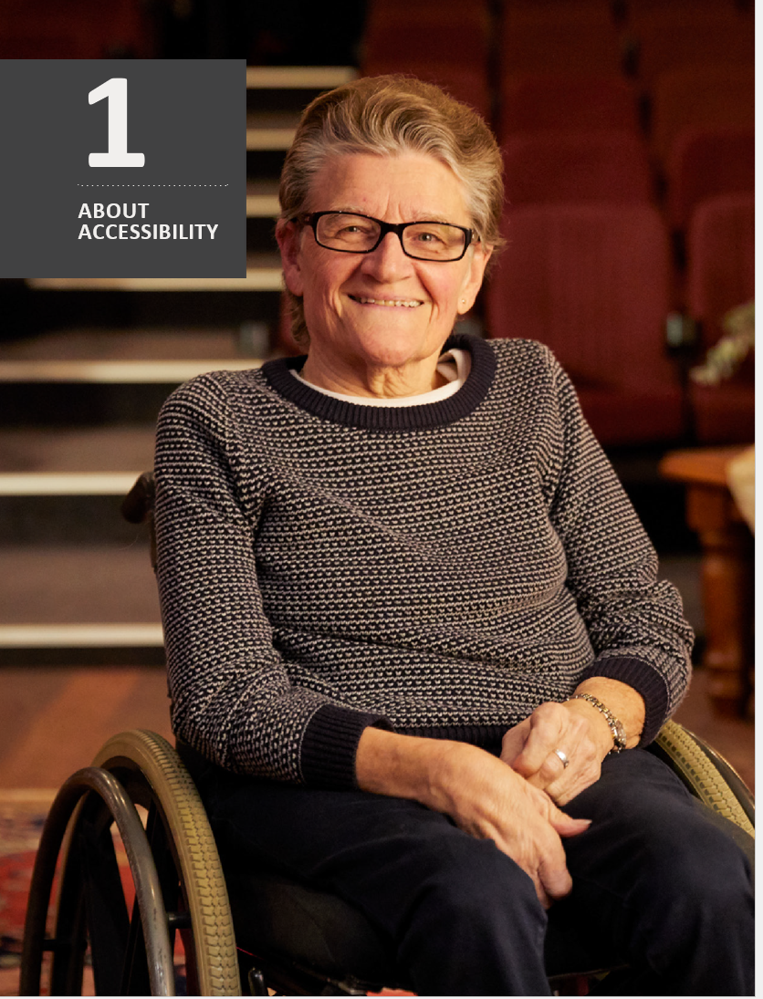

What is digital accessibility?

The following essentials highlight the significance of digital accessibility in building an inclusive society, where individuals with disability can access information without restrictions.

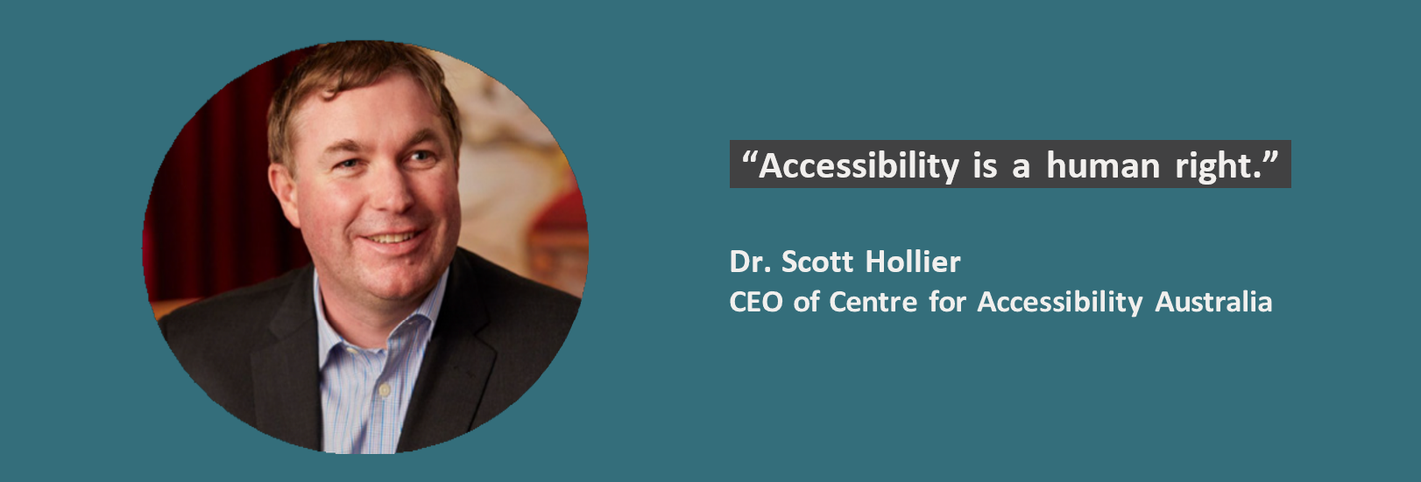

Digital Accessibility

Digital accessibility refers to the inclusive design and development of digital content, tools, and technologies. The goal of digital accessibility is to provide equal access and usability for all by eliminating barriers that might otherwise hinder their interaction with digital information and services.

The two essentials for effective digital accessibility are:

1. Assistive Technology
People with disability require accessibility support through assistive technology. These technologies help bridge the gap by providing features like screen readers, voice commands, or specialized input devices tailored to different needs.

2. Accessible Content
Digital content must be created in a way that supports individuals with disability, ensuring compatibility with assistive technology. This involves designing digital materials, such as websites and documents, in a manner that allows screen readers to interpret text, alternative text for images, and other accommodations for those who may have visual, auditory, or motor disability.

Why is accessibility important?
- Ensures equal access to information and communication for people with disability, promoting education and workforce participation.
- Accessible digital content and technology enable individuals with disability to have autonomy and independence. It allows them to perform tasks like online shopping, banking, and social networking without assistance, promoting greater inclusion in society.
- Many essential services, including healthcare and government services, are increasingly available online. Digital access ensures that individuals with disability can access these services without physical barriers.
- Promotes social and cultural participation for people with disability, enabling them to engage in online activities and communities.
- Legal frameworks, like Australia’s Disability Discrimination Act 1992, mandate accessible digital content to ensure equal access for people with disability.
- Accessible digital resources are essential for students with disability. They enable them to participate in online learning, access educational materials, and interact with teachers and peers, promoting equal educational opportunities.
- Many jobs and employment opportunities are linked to digital technologies. Providing digital access allows individuals with disability to compete in the job market and pursue a wider range of career options.

The research

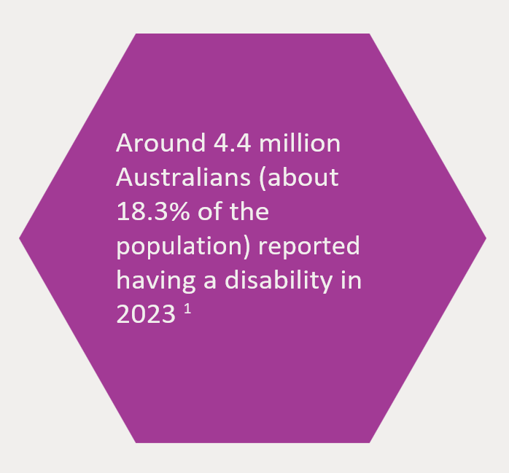
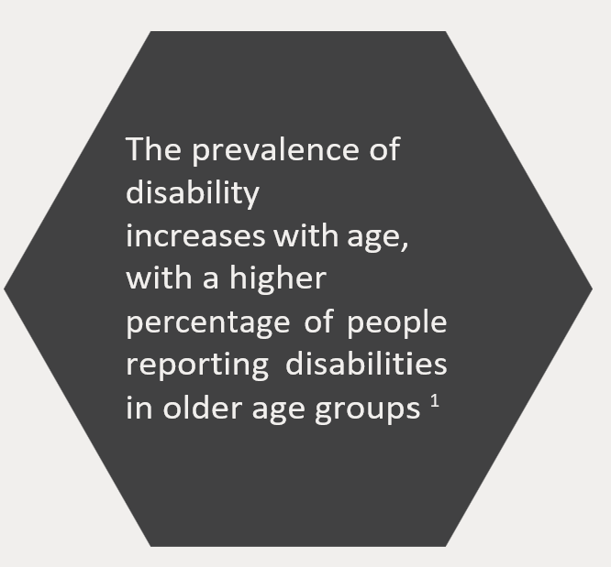
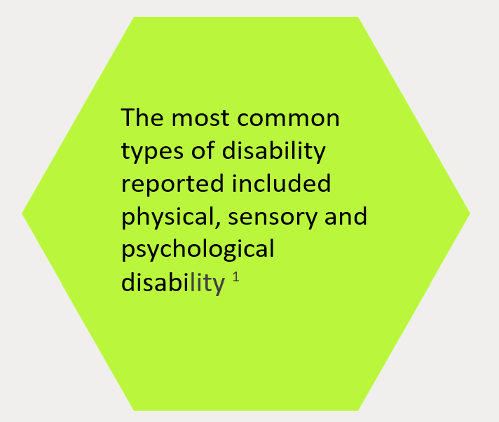
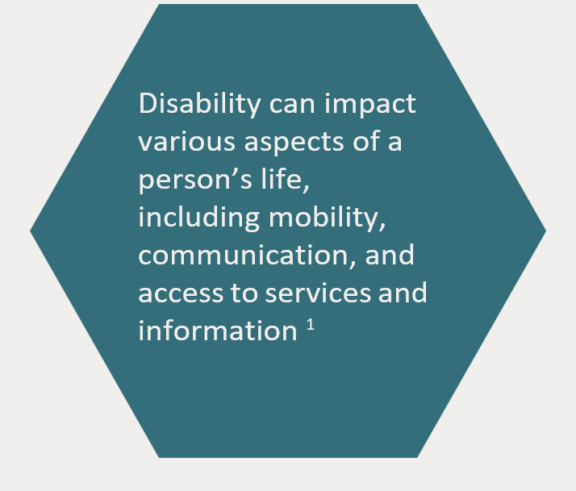

Foot note 1: Disability, Ageging and Carers, Australia: Summary of Findings (2018). Australian Bureau of Statistic.

What people have to say

Debra Ruh
CEO and Founder of Ruh Global IMPACT

“Accessibility benefits everyone. We must make it part of the DNA of every organisation and agency in the world”

Emily Ladau
Disability rights activist, speaker, and author of Demystifying Disability: What to Know, What to Say and How to be an Ally

“Inaccessibility isn’t just personal; it’s a structural and systemic issue.”

Tim Berners-Lee
Inventor of the World Wide Web

“The power of the Web is in its universality. Access by everyone regardless of disability is an essential aspect.”

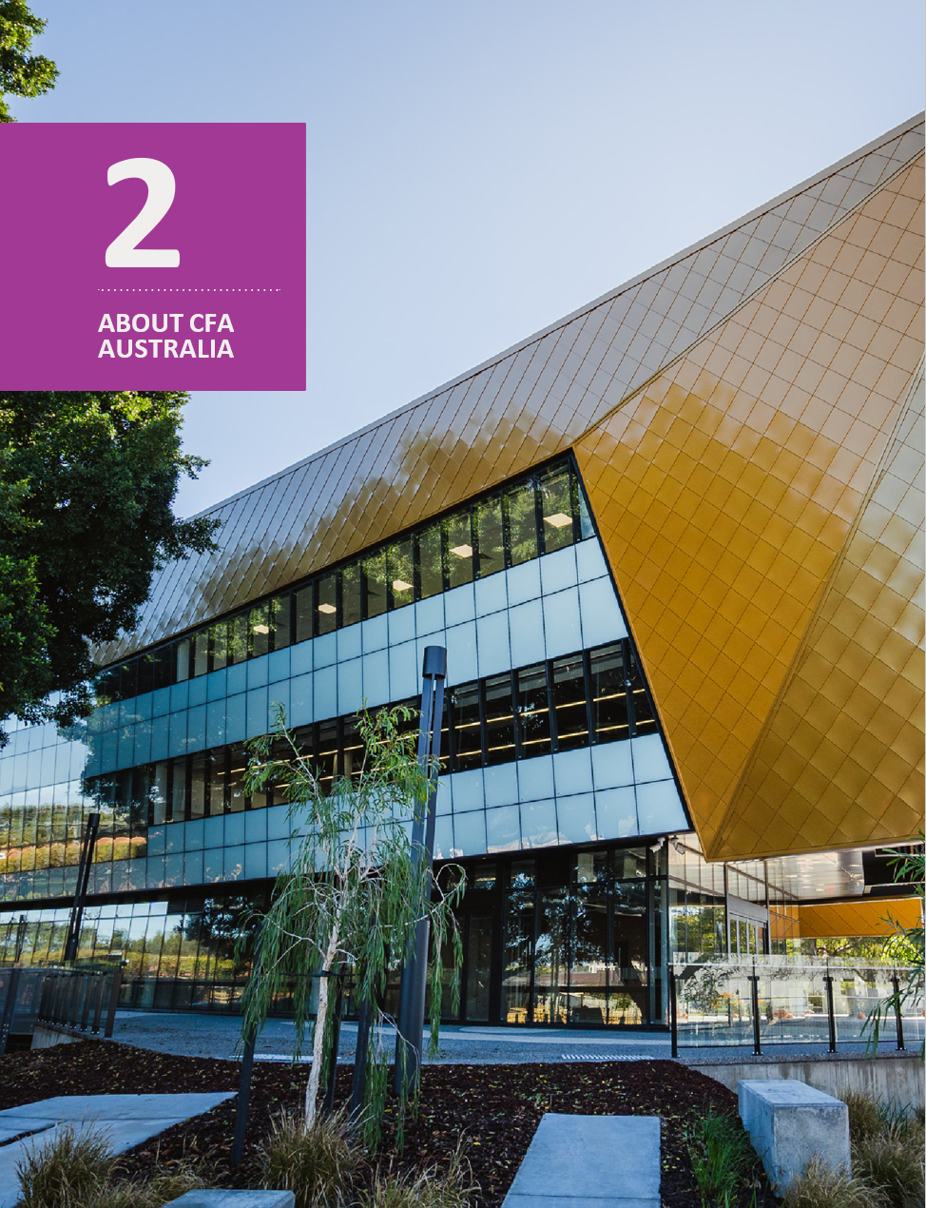

What is CFA Australia?

Centre for Accessibility Australia (CFA Australia) stands as an award-winning not-for-profit organisation whose core vision is to advocate for digital accessibility throughout Australia, ensuring equitable access to technology and the internet for people with disability.

Establishment & Purpose

Established in 2018, Centre for Accessibility Australia was founded with the primary objective of propelling the accessibility movement forward. Through a multifaceted approach, CFA Australia engages in advocacy, research, training services, auditing services, and the organisation of celebratory events, such as the prestigious Australian Access Awards.

Mission

In today’s rapidly evolving digital landscape, for individuals with disability, the internet often remains largely inaccessible, despite the presence of legal frameworks aimed at promoting accessibility.

CFA Australia’s mission is clear: to bridge the accessibility divide through positive reinforcement by emphasizing the critical significance of equal access. Dr. Scott Hollier, CEO of CFA Australia, himself legally blind, underscores the transformative impact of accessibility, which can be the difference between autonomy and dependence on others.

Our Work

We at CFA Australia are resolute in our pursuit of a more accessible and equitable digital landscape. The year ahead holds the promise of further progress as we tirelessly advocate for accessibility throughout Australia.

Advocacy
We serve as vocal advocates for those who require accessible digital environments. We actively engage with stakeholders, policymakers, and organisations to create awareness and drive positive change

Empowering Technology
CFA Australia is committed to providing the knowledge and tools necessary for individuals and organisations to embrace digital accessibility, ensuring a more inclusive technological landscape.

Research
Through our research initiatives, we deepen our understanding of the evolving world of accessibility, identifying challenges and seeking innovative solutions.

Auditing Services
We offer auditing services to organisations, helping them identify and rectify accessibility issues, thereby contributing to a more accessible digital sphere.

Our Team

The Board at CFA Australia comprises a dedicated and knowledgeable group of staff and volunteers, bringing extensive expertise in digital accessibility and disability services.
This year, CFA Australia is delighted to announce Dawn McAleenan as a new member of
the board.

Board Members
- Marina Re (Chair)
- Jackie Weinman (Deputy Chair)
- Stanley Lai (Treasurer)
- Dr. Michelle Bunn (Secretary)
- Scott La Vertu
- Yuemei Lim
- Stewart Luxton
- Dawn McAleenan

CFA Australia Founding Partners
- Dr. Scott Hollier (Chief Executive Officer)
- DADAA
- Media on Mars

Admin Team
- Anna Dantschin
- Colleen Hunter
- Laetitia Thompson

Auditing Team
- Aarthi Gurunathan
- Christopher Edwards
- Chris Leighton
- Dhiren Patel
- Nick Kapirnas

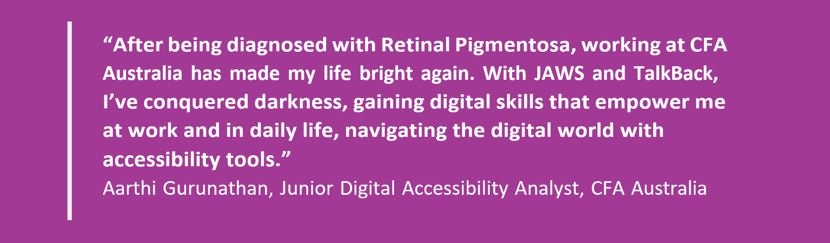

Our Workspace

This period of rapid expansion comes hand in hand with a strategic move to a new workspace in the newly refurbished, Belmont Hub.

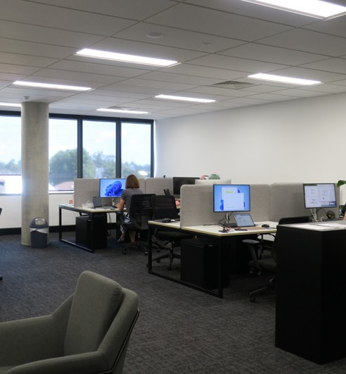

This vibrant hub, sponsored by Lottery West, is home to a range of charities and not-for-profit organisations. CFA Australia now finds itself among a network of like-minded organisations, fostering a sense of innovation and collaboration.

The move to Belmont Hub symbolises CFA Australia’s continuous growth and commitment to digital accessibility, while positioning the organisation at the heart of a community dedicated to making a positive impact to society.

Stay tuned for more exciting developments from CFA Australia as we embark on this new phase of our mission and continue to grow!

Australian Access Awards 2023

Every 2 years, CFA Australia hosts the Australian Access Awards to celebrate and recognise organisations all around Australia doing tremendous work in the digital accessibility scene. CFA Australia is delighted to share that, after our successful 2019 and 2021 awards, 2023 will see the return of the Australian Access Awards once again.

For more information on the 2023 Australian Access Awards, please refer to the link provided on CFA Australia’s website.
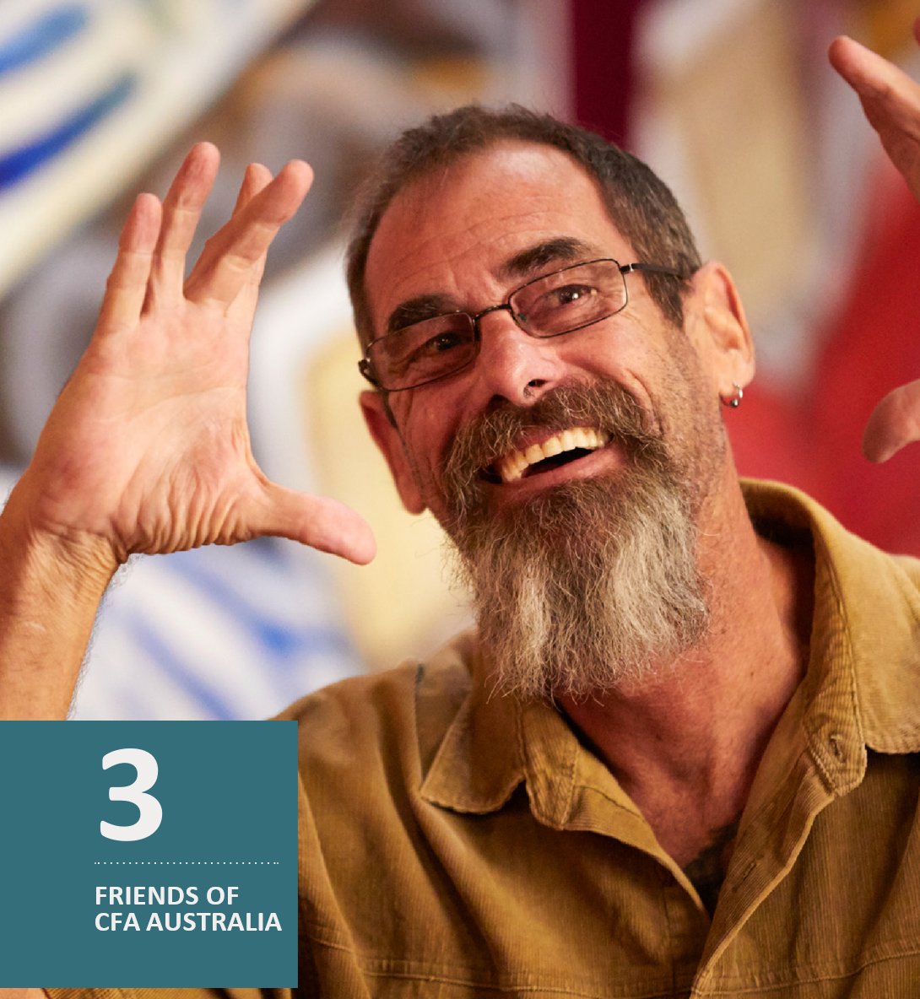

Membership

Join the Accessibility Revolution with CFA Australia! While the world is moving towards inclusivity, digital barriers continue to persist for people with disability.

Our Friends of CFA Australia program lets individuals and companies support accessibility efforts while enjoying membership benefits which includes discounts on audits, training, and consultancy services.

Your contribution strengthens the services CFA Australia provides such as our free Helpdesk, closing the gap to an inclusive online world for everyone.

Visit our CFA Membership Page for further details on membership and to join us on our journey in the promotion and advocacy of digital inclusion for all.

In addition to actively supporting the employment of people with disability and dedicating to long-term change, members receive a number of perks:

Membership Benefits

- One free half-day online or face-to-face CFA Australia Training session
- Discounts on subsequent training sessions
- Unlimited email support from Helpdesk
- Two hours free phone support which can be used in
- 15-minute Increments (more support can be provided at an additional cost)
- 20% discount on events
- 10% discount on speaking engagements
- Friends of CFA Australia Badge for display on your business profiles / websites
- Exclusive invitation to our State of Accessibility Digital Address (twice a year)
- Subscription to the CFA Australia Bimonthly newsletter
- Annual accessibility review (free for business members)

For more information about our membership packages:

Visit our Memberships website
Contact us: admin@accessibility.org.au

Get social with CFA Australia!

Another way you could be a part of the social movement that is digital inclusivity is by joining the conversation on digital accessibility on CFA Australia’s socials!

Helpdesk

In our ongoing commitment to supporting people with disability and organisations on their journey towards digital accessibility, we are proud to introduce our Helpdesk service. This service is facilitated by our disability-led team, ensuring that expert guidance and assistance is provided.

Our free Helpdesk is designed to provide important support to people with disability, their families, and carers.

Whether you’re looking to enable disability-specific accessibility features on your device or seeking assistance with everyday online services, our Helpdesk is here to help. We are also always prepared to provide guidance on finding alternative accessible websites or apps that can support your daily activities.

CASE STUDY

In a collaborative effort, five of Western Australia’s leading universities joined forces with CFA Australia to support a research project aimed at enhancing digital accessibility standards for students with disability.

This project, known as “Higher Education for All,” was funded by the WA Department of Communities and emerged in response to the needs and concerns raised by 27 current and prospective students with disability who reached out to CFA Australia for assistance in navigating university websites.

The research brought to light prevalent digital accessibility challenges on university websites, encompassing issues related to colour contrast, navigation, heading structure, PDF accessibility, and visible focus. Moreover, students underscored the importance of accessible campus maps and improved communication channels with universities for disability-specific support and addressing complaints related to digital accessibility.

Participating universities underwent com- prehensive training to equip their website management teams with the knowledge and tools needed to enhance and sustain compliance with the World Wide Web Consortium’s (W3C) Web Content Accessibility Guidelines (WCAG) 2.1.

This pioneering study, marking a first in Western Australia, has not only offered invaluable insights and recommendations but has also provided a vital benchmark for other higher education institutions as CFA Australia extends its commitment to improving digital accessibility in this sector.

For a detailed analysis of the findings and recommendations, you can explore more on our website.

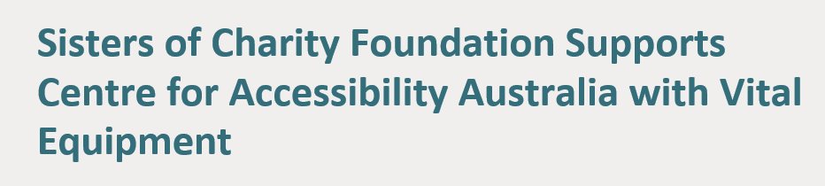

In a generous display of support, the Sisters of Charity Foundation awarded CFA Australia a community grant that has allowed for the expansion of capacity to advocate and provide services in relation to digital accessibility. The grant provided CFA Australia with essential IT equipment.

This contribution supports CFA Australia particularly through the strengthening of Helpdesk services, which provide free assistance to individuals with disability, their families, and carers who encounter challenges in accessing online content.

Dr. Scott Hollier, CEO of CFA Australia, expressed his gratitude to the Sisters of Charity Foundation, emphasizing that their support is instrumental in advancing the work of CFA Australia.

As a disability-led not-for-profit organisation, this funding serves as a crucial means for lasting support and advocating for people with disability, furthering the goal of making digital content accessible to all.

The Centre for Accessibility Australia extends its heartfelt thanks to the Sisters of Charity Foundation for their invaluable support.

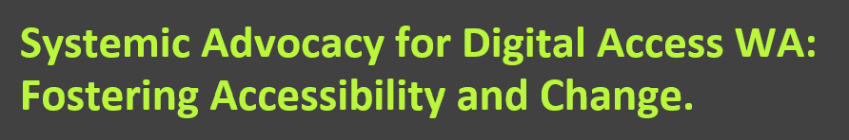

The ‘WA State Disability Advocacy Program: The Digital Access WA Project’, is being led by CFA Australia alongside the Behaviour Change Collaborative (BCC) to advance digital accessibility for people with disability in WA.

This comprehensive project, which is being supported by the Department of Communities in WA, encompasses activities such as conducting digital audits, developing training programs, amplifying the voices of people with disability, and advocating for policy changes. Through a multi-faceted approach, the project aims to overcome digital access barriers, empower individuals with disability, and create a more inclusive digital landscape for all residents of WA.

CFA Australia has 7 main objectives. Firstly, as part of the ‘Discovery Project’, CFA Australia will source for individuals with disability who are open to sharing their experiences and insights in relation to digital accessibility.

Secondly, to ensure that appropriate benchmarks on the state of accessibility services in WA are acknowledged before the project goes into full flow, CFA Australia has organised for pre- and post-audit surveys for NFP organisations to measure their improvements in digital access knowledge as part of our ‘Engage, Survey, Report’ objective.

Thirdly, CFA Australia will be conducting ‘Discovery Workshops’, both in-person and online, to address the integration of digital access into work processes and practical digital access techniques.

Fourthly, free digital accessibility audits will be provided to NFP organisations to ensure that their websites and applications meet accessible requirements based on the Web Content Accessibility Guidelines (WCAG). Fifthly, a pivotal aspect of the Systemic Advocacy Project involves consultation with legal advisors within the state to drive policy changes for increased digital access especially for people with disability.

To mark the end of the Systemic Advocacy Project, CFA Australia will be hosting an event for everyone involved to celebrate the meaningful engagement within digital accessibility. This would include a ‘Digital Access WA Video’ showcasing success stories. Lastly, together with BCC, CFA Australia will produce an ‘Outcomes Report’ and recommendations for next steps, an ‘Impact Measurement Report’, and the creation of an online data registry of accessibility in WA.

The first year of the Digital Access WA Project has been progressing well with an expression of interest completed to engage NFPs in our audits, with numerous audits being completed. Furthermore, a fantastic workshop to support digital access in partnership with the City of Belmont, as well as the other aspects of the project are progressing well in their planning for the next financial year. We look forward to the continued progress
of this initiative and the positive impact it will have on individuals with disability in Western Australia. Stay tuned for more updates on our journey to create a more inclusive digital landscape for all.

ARTICLE

W3C & Plain Language ISO

Just like previous years, the World Wide Web Consortium (W3C) Web Accessibility Initiative (WAI) has again produced numerous valuable new international standards and guidance on digital accessibility.

4 new members were welcomed into the W3C Advisory Committee in conjunction with the incorporation of W3C as a not-for-profit organisation.

W3C WAI published the Accessibility of Remote Meetings Note. Dr. Scott Hollier led the Research Questions Task Force (RQTF) of the Accessible Platform Architectures (APA) Working Group in the development of the Note, ensuring that personal lived experience with disability was portrayed accurately in the decision-making processes. The Note discusses the necessity for remote meeting platforms to adhere to accessibility guidelines when developing their products and make sure that all users can access the content.

The most recent version of the EPUB standard, Electronic Publication 3.3 (EPUB 3.3), was also published by the World Wide Web Consortium (W3C) as a W3C Recommendation. EPUB establishes a coding format for digital publications and documents to be distributed and exchanged. W3C recently declared WAI Accessible Rich Internet Applications 1.2 (WAI-ARIA 1.2) as the W3C recommended standard. WAI-ARIA 1.2 introduces new features that enhance interoperability with assistive technologies.

W3C WAI also released the first iteration of the Course List – Digital Accessibility Education, Training, and Certification. The list assists users in making well-informed choices about how to obtain accreditations related to digital accessibility.

CFA Australia is excited to share that the International Plain Language Federation (IPLF) has successfully launched the International Organisation for Standardization’s (ISO) project to develop a comprehensive internationally recognised plain language standard, ISO 24495-1.

CFA Australia have played a pivotal support role in the formation of this standard as the use of appropriate plain language is highly beneficial for people with various disabilities such as a cognitive disability.

CFA Australia looks forward to further progression in the digital accessibility space alongside W3C.

Accessible consumer developments

There have been vast developments in the accessibility of mobile interfaces in the past year. Apple introduced new software features for cognitive accessibility such as ‘Assistive Access’, reducing cognitive load by simplifying interfaces to their most key aspects.

On the other end, Android received vital improvements for people with hearing related disabilities through the enhancement in the sounds of alerts and audio descriptions.
Web interfaces also received major improvements across various browsers. Firefox had a rehaul in its 109 and 113 updates, seeing distinct improvements for screen reader users.

Microsoft Edge oversaw the inclusion of live caption audio transcriptions while Google rolled out its ‘Reading Mode’ to its Chrome browser on computers. Web interfaces often remain difficult to use without an accessible operating system.
In its 22H2 update for Windows 11, Microsoft rolled out many new accessibility features, the standout being the enabling of live captioning of any audio source in Windows and improved voice control to help people with mobility issues.

CFA Australia has also been keeping track of popular accessible applications and tools. For example, Zoom implemented a ‘Sign Language Interpretation View’ feature which allows meetings to host up to 20 sign language interpreters. Another exciting development has been Adobe’s AI automated PDF Accessibility Tags which automates the tagging of PDF documents, enabling proper reading sequences for assistive technologies.

Throughout the year, innovative new devices have surfaced, empowering determination and creativity within digital accessibility. One such device is the Google-certified SmartVision smartphone which was specifically designed for people who are blind or with low vision.

There has also been innovation in the entertainment sphere. Over the past year, Netflix has begun providing viewers the option to customise the style and size of subtitles and closed captions. This would benefit people who are deaf, hard of hearing, or have low vision.

This leads us to the very exciting world of gaming. Throughout FY 22/23 we have
not only seen new accessible video games being released, but major accessibility reworks being done on older game titles as well. For example, the ‘Dead Space’ remake, enabling accessibility features such as subtitles, colourblind mode and aim assistance.

As part of our objective in the promotion and support of digital accessibility, CFA Australia continues to ensure that up and coming, as well as newly released accessible content is constantly kept up to date on our News’ page moving forward each year.

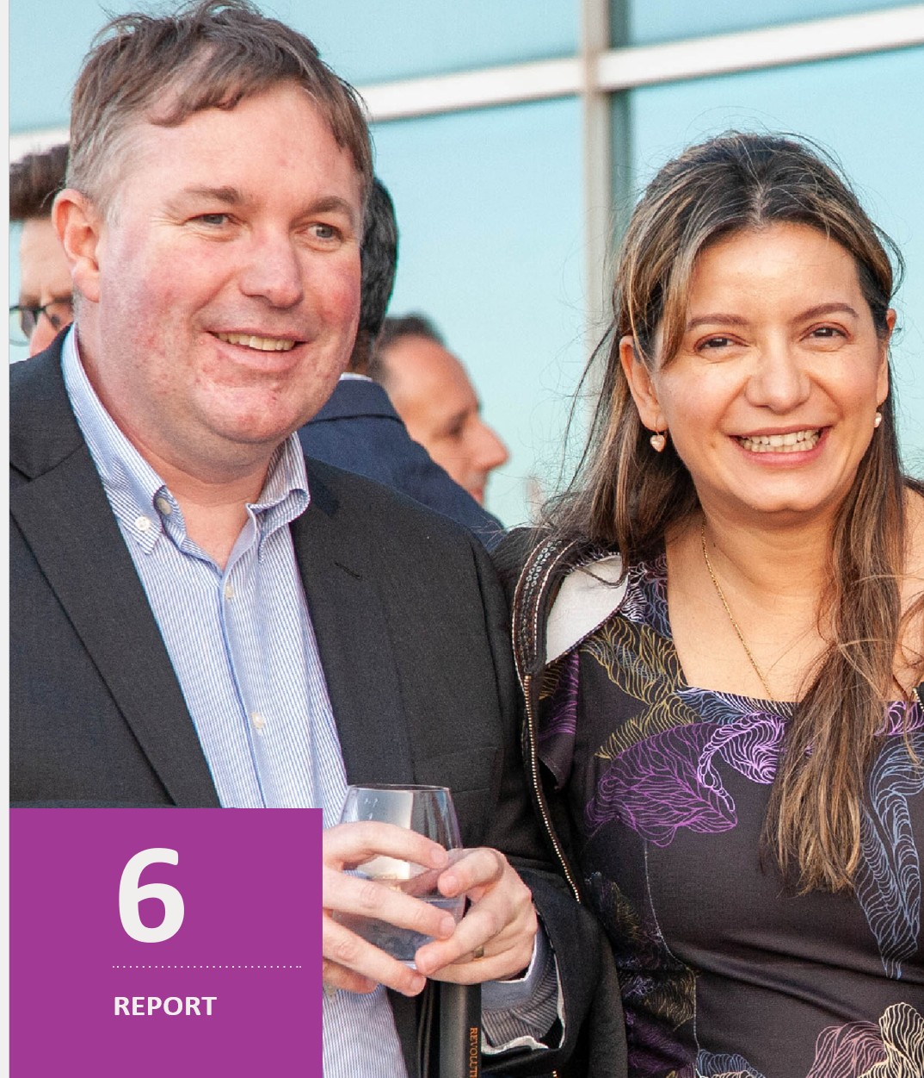

Treasurer’s Report
With the ongoing cost of living crisis, the third year of the organisation has been financially successful, thanks to the hard work from Scott, our CFA Australia staff, our bookkeeper Antonella and the directors on the Board.

We have taken further big steps forward this year as an organisation, which is something we can be proud of.

The 2023 financial year was the beginning of the partnership with the Department of Communities. This partnership allowed the organisation to give new opportunities, grow its staff and move in to offices in the Belmont Hub. We were able to purchase office equipment for our staff and provide them with a great place to work.

We have increased our income thanks to increasing our grants, memberships and audits.
Overall we have been able to grow it by over 85%. This was due to the demand of our services and through the relationships with other organisations we were able to build. Due to the increase in organisation activity, we have an increase in expenditure from the large growth from wages, rent and the use of consultants.

Compared to the previous year, we’ve had a reduced profit of $63,457 for the 2023 financial year.
Our balance sheet has been able to grow, with our assets now including the recently purchased office equipment, thanks to conservative investment policies and our strong bank balance. The organisation is sitting in a strong, stable financial position. The organisation can cover any debts which are due.

For the next financial year, I am expecting the organisation to continue on its strong financial position, with a small growth in income and expenditure.
Overall I am extremely proud of the organisation and look forward to the next financial year.

Stanley Lai
Treasurer

Financial Report

Statement by directors of the board

In the opinion of the board the financial report:
- Centre for Accessibility Australia Ltd (Company) is not a reporting entity because there are no users dependent on general purpose financial statements. Accordingly, as described in note 1 to the financial statements, the attached special purpose financial statements have been prepared for the purposes of complying with the reporting requirements of the Company’s constitution and the Australian Charities and Not-for-Profit Commissions Act 2012
- The attached financial statements and notes thereto have been prepared in accordance with the accounting policies prescribed in note 1 to the financial statements and to comply with the Australian Charities and Not-for-Profit Commissions Act 2012, the Australian Charities and Not-for-Profit Commissions Regulations 2013 and other mandatory professional reporting requirements;
- At the date of this statement, there are reasonable grounds to believe that the company will be able to pay its debts as and when they fall due and
- The attached financial statements and notes thereto give a true and fair view of the Company’s financial position as at 30 June 2023 and its performance for the financial year ended on that date.

Signed in accordance with a resolution of the directors made pursuant to section 60. 15(2)
of the Australian Charities and Not-for-Profit Commissions Regulation 2013.

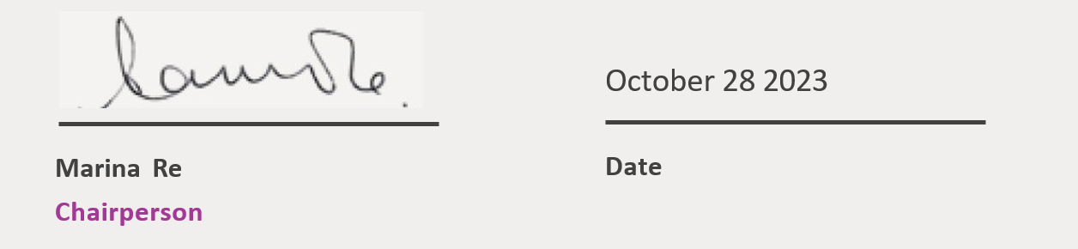

Centre for Accessibility Australia Ltd

Statement of Profit and Loss
For the year ended 30 June 2023

2023 2022
Trading Income
Donations | - | 100
Grants | 662,239 | 164,000
Sales | 263,799 | 344,018
Wage Subsidy | 16,000 | -
Total Trading Income | 942,038 | 508,118
Gross Profit | 942,038 | 508,118
Operating Expenses
Advertising | 375 | 1,581
Annual Leave | 14,042 | 4,684
Bank Fees | 15 | 105
Conference | 1,507 | 188
Consulting & Accounting | 362,154 | 181,945
Depreciation | 26,448 | 3,963
Freight & Courier | 3,079 | 1,372
General Expenses | 2,693 | -
Insurance | 5,049 | 3,517
Merchant Fee | - | 74
Office Expenses | 6,676 | 2,533
Printing & Stationery | 1,750 | 730
Rent | 20,599 | -
Repairs and Maintenance | 67 | -
Software | 49 | -
Stripe Fees | 727 | 642
Subscriptions | 7,525 | 1,970
Superannuation | 32,552 | 6,674
Telephone & Internet | 1,060 | 417
Travel - National | 16,923 | 3,279
Wages and Salaries | 375,209 | 98,775
Total Operating Expenses | 878,581 | 312,451
Net Profit | 63,457 | 195,667

Statement of Financial Position
As at 30 June 2023

30-Jun-23 30-Jun-22
Assets
Bank
Cash at Bank | 489,248 | 290,199
Stripe AUD | 554 | 1,622
Total Bank | 489,802 | 291,820
Current Assets
Accounts Receivable | 8,065 | 2,050
Prepaid Expenses | - | -
Total Current Assets | 8,065 | 2,050
Non-Current Assets
Computer Equipment | 26,889 | -
Accumulated Dep - Computer Equipment | (26,889) | -
Office Equipment | 21,938 | -
Accumulated Dep - Office Equipment | (1,710) | -
Total Non-Current Assets | 20,228 | -
Total Assets | 518,095 | 293,870
Liabilities
Current Liabilities
Accounts Payable | 24,475 | 233
GST | 17,261 | 9,401
PAYG Withholdings Payable | 13,014 | 2,880
Provision for Annual Leave | 22,652 | 8,611
Superannuation Payable | 8,705 | 2,099
Wages Payable - Payroll | 15,236 | -
Upsent Grant | 82,647 | -
Total Current Liabilities | 183,991 | 23,224
Total Liabilities | 183,991 | 23,224
Net Assets | 334,104 | 270,647
Equity
Current Year Earnings | 63,457 | 195,667
Retained Earnings | 270,647 | 74,980
Total Equity | 334,104 | 270,647

Statement of Cash Flows
For the year ended 30 June 2023

2023 2022
Operating Activities
Receipts from customers | 1,018,671 | 316,862
Payments to suppliers and employees | (774,014) | (295,462)
Net Cash Flows from Operating Activities | 244,657 | 21,400
Investing Activities
Payment for property, plant and equipment | (46,676) | (3,963)
Net Cash Flows from Investing Activities | (46,676) | (3,963)
Net Cash Flows | 197,981 | 17,437
Cash and Cash Equivalents
Cash and cash equivalents at beginning of period | 291,820 | 274,383
Cash and cash equivalents at end of period | 489,801 | 291,820
Net change in cash for period | 197,981 | 17,437

Statement of Change in Equity
For the year ended 30 June 2023

2023 2022
Equity
Opening Balance | 270,647 | 74,980
Current Year Earnings | 63,457 | 195,667
Total Equity | 334,104 | 270,647

Notes to financial statements
For the year ended 30 June 2023

Note 1: Statement of significant accounting policies

The Directors have prepared the financial report on the basis that the Centre for Accessibility Australia Ltd (Company) is not a reporting entity as there are unlikely to exist users who are unable to command the preparation of reports tailored so as to satisfy specifically all of their information needs. Accordingly, this Special Purpose Financial Report has been prepared for the purposes of complying with the reporting requirements of the Company's constitution and the Australian Charities and Not-for-Profit Commissions Act 2012.

The financial report has been prepared on an accruals basis and is based on historical costs and does not take into account changing money values or, except where specifically stated, current valuations of non-current assets.

AASB 101 - Presentation of Financial Statements AASB 107 - Statement of Cash Flows AASB 108 - Accounting Policies, Changes in Accounting Estimates and Errors
AASB 1048 - Interpretation of Standards AASB 1054 - Australian Additional Disclosures

The accounting policy adopted below relating to income and employee entitlements are not entirely consistent with the Australian Accounting Standards (AAS). Hence, the financial statements overall do not comply with the recognition and measurement requirements of some of the AAS. The organisation is yet to assess the AAS, which the financial statements do not comply.

The financial report has been prepared on an accruals basis and is based on historic
costs and does not take into account changing money values.
The following material accounting policies, which are consistent with the previous period unless otherwise stated, have been adopted in the preparation of this financial report.

- Revenue Recognition

All revenue is stated net of the amount of goods and services (GST) Audit and Consulting Fees Revenue from services delivered are recognised as income once the services had been delivered.

Income received for services not delivered at year-end are recorded as income received
in advance on the statement of financial position.

- Income Tax

The Company is a non-profit organisation and thus exempted from income tax liability
by virtue of 23(3) of the Income Tax Assessment Act.

- Goods and Services Tax (GST)

Revenues, expenses and assets are recognised net of the amount of GST, except where the amount of GST incurred is not recoverable from the Australian Taxation Office. In these circumstances the GST is recognised as part of the cost of
acquisition of the asset or as part of the expense.

d) Cash and Cash Equivalents
Cash & Cash equivalents in the statement of financial position comprise cash at bank and in hand and short term deposits with an original maturity of three months or less where the investments is convertible to know amounts of cash and is subject to insignificant risk of changes in value.

e) Property, Plant and Equipment

Plant and equipment is stated at historical cost less accumulated depreciation and impairment. Historical cost includes expenditure that is directly attributable to the acquisition of the items.

Depreciation is calculated on either a diminishing value or straight-line basis to write off the net cost of each item of property, plant and equipment over their expected useful lives as follows:

Office equipment 10% - 100% Computer Equipment - 100%

The residual values, useful lives and depreciation methods are reviewed, and adjusted if appropriate, at each reporting date.

An item of property, plant and equipment is derecognised upon disposal or when there is no future economic benefit to the incorporated association. Gains and losses between the carrying amount and the disposal proceeds are taken to profit or loss.

Note 2: Reconciliation of Net Cash Provided By/Used in Operating Activities to Net Profit

Operating Profit (Loss) 63,457 195,667
Adjustments for:
Depreciation | 26,448 | 3,963
(Increase)/ Decrease in Trade & Other receivables | (6,015) | (55)
(Increase)/ Decrease Prepaid Expenses | - | 20,000
Increase/ (Decrease) in Trade and Other payables | 146,726 | (11,658)
Increase/(Decrease) in Income Received in Advance | - | (191,200)
Increase/(Decrease) in Annual Leace Provision | 14,041 | 4,683
Cash used/ provided by operating activities | $244,657 | 21,400

Note 3: Members Guarantee

The Company is a registered as a company limited by guarantee. If the Company is wound up, the constitution states that each member is requited to contribute a maximum of $1 each towards meeting any outstanding obligations on the Company.

